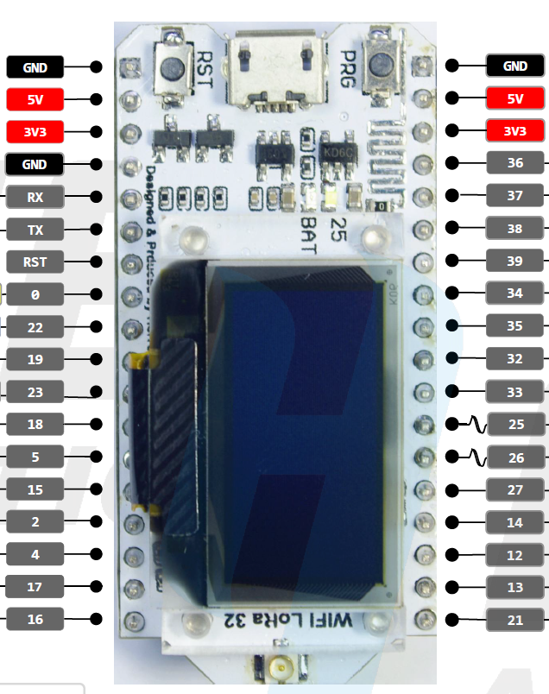

GPS TXD

SDA

SDS01 TXD

SCL

Select Button

Down Button

UP Button